**Tribhuvan University**

Kirtipur, Kathmandu, Nepal

**Department of Humanities & Social**

**Science**

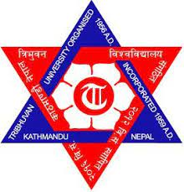

A Lab Report On

**Subject Name**

**Subject Code**

Report submitted in partial fulfillment of the requirements for the 4th Semester

**Bachelor in Computer Applications**

*Submitted by:*

**Student Name Roll No.**

**Under the guidance of**

**Subject Teacher Name**

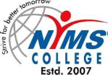

**NIMS College**

**Lagankhel, Lalitpur, Nepal**

**2025**

**NIMS College**

**Lagankhel, Lalitpur**

**Nepal**

**Department of Bachelor in Computer Applications**

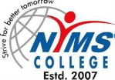

***Certificate***

Certified that the Lab Report work entitled of **“Subject Name and Subject Code ”** carried out by **student name & Roll No.** , a Bonafide student at NIMS College , in partial fulfillment for the award of BCA department of the **TRIBHUVAN UNIVERSITY**, Kirtipur, Kathmandu, Nepal during the academic year 2020. It is certified that all corrections/ suggestions indicated for internal assessment have been incorporated in the report deposited in the department library. The Report has been approved as it satisfies the academic requirements in respect of **Subject Name and Subject Code** report work to prescribe for the said degree.

**_____________ _____________**

**Teacher Name External Examiner**

**Subject Name**